PSB Speakers Announces the Launch of the Alpha iQ, Streaming Powered Speakers with BluOS
  - Innovative all-in-one audio system integrates control, source, and amplification into a pair of bookshelf speakers
White Alpha iQ speakers in an office environment.

CEDIA 2022, DALLAS, UNITED STATES, September 20, 2022– PSB Speakers, long renowned for excellence in loudspeaker design, announces the Alpha iQ, Streaming Powered Speakers with BluOS, an all-in-one audio system that sets a new benchmark for modern, tangle-free, audiophile-grade listening. Attendees of the CEDIA Expo will be among the first to experience the product. PSB’s Alpha iQ will be available for pre-order online on October 19, 2022, for US$1,499 / GBP£1,299 / EUR€1,499 / CDN$2,199. Retail availability will begin in late November 2022.

Comprising two bookshelf speakers with built-in amplifiers and a network streamer based on the award-winning BluOS multi-room music platform, the Alpha iQ lets listeners enjoy PSB’s acclaimed “True to Nature” sound with more than 20 streaming services and hundreds of Internet radio stations. The Alpha iQ has a wide array of inputs so users can connect source components such as a turntable, TV, disc player, or game console. Listeners can share their music over a home network with up to 63 other BluOS-enabled components.

A World of Music
Setting up and using the Alpha iQ is simple. Plug the speakers into power outlets, then connect the Alpha iQ to a home network using the intuitive BluOS Controller app on a smartphone, tablet, or personal computer. Now the speakers are ready to play music from more than 20 streaming services supported by BluOS, including several that offer high-resolution audio, such as Amazon Music Ultra HD, Deezer, Qobuz, and Tidal. BluOS also provides access to hundreds of Internet radio stations around the world, covering all musical genres.

The Alpha iQ has built-in two-way Bluetooth, with support for the high-quality aptX-HD codec for wireless streaming from any mobile device. Apple AirPlay 2 compatibility allows listeners to stream CD-resolution music from any app on an iPhone, iPad, or Mac. Spotify Connect and Tidal Connect are both supported, so listeners can cue up music in the apps for those services, then transfer playback to the Alpha iQ.

Tangle-free
Users don’t have to clutter their living spaces with speaker wires to enjoy “True to Nature” sound from the Alpha iQ. The left and right speakers communicate via a wireless link that can cover most rooms in an average-size home, so that music stays synched and clear regardless of speaker placement.
Pair of black Alpha iQ speakers from above.

Audiophile-Grade
Available in satin white and satin black finishes, the Alpha iQ has a sleek, modern design. Inside each enclosure is a 4″ polypropylene mid-bass driver with steel basket and rubber surround, and a 0.75″ aluminum dome tweeter with neodymium magnet and ferrofluid damping.

Each woofer has its own 60W class-D amplifier, and each tweeter its own 30W class-D amp, for total system output of 180W. Thanks to their powerful amplifiers, tuned bass ports, and DSP-enabled low-frequency extension, PSB’s Alpha iQ speakers can deliver bass output that completely belies their diminutive size.

The Alpha iQ employs a DSP-based active crossover. As with many PSB designs, the tweeter is placed below the woofer. This arrangement provides greater flexibility in listener position because the blend between woofer and tweeter remains consistent whether one is sitting or standing.

High Resolution
The Alpha iQ’s audiophile-grade DAC supports resolution to 24-bit/192kHz and has full MQA decoding and rendering capability for high-res streaming from Tidal. BluOS also lets listeners enjoy four stations with MQA-encoded high-resolution music from Radio Paradise.

Well Connected
The Alpha iQ boasts an extensive range of input and outputs. The primary speaker has a built-in MM phono preamp and RCA jacks plus ground terminal, so vinyl fans can connect a turntable. An HDMI ARC port lets users experience sound with TV and movies. There’s also an optical input for connecting a disc player or game console, and a 3.5mm auxiliary input for connecting analogue sources. Listeners can also use the BluOS app to play music files stored on an external drive connected to the Alpha iQ’s USB port.

Output Options
For late-night listening, listeners can connect a pair of headphones to the combined optical / headphone jack or via two-way Bluetooth. For enhanced bass, there’s a subwoofer output. When a subwoofer is connected, BluOS engages a low-pass filter for the sub and a high-pass filter for the mains, which frees the Alpha iQ from having to produce deep bass sounds.

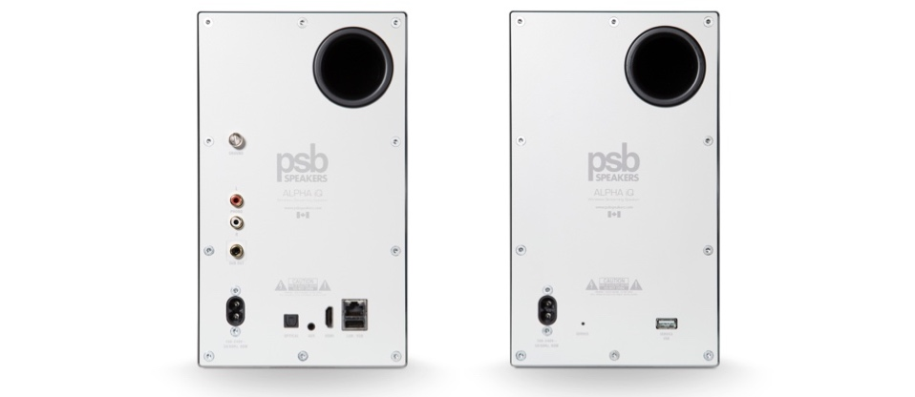
Pair of white Alpha iQ speakers from rear.

Smart and Simple
Listeners can manage every aspect of the Alpha iQ’s operation using the rich, robust BluOS Controller app, which is available for Android, iOS, macOS, and Windows. For making quick adjustments without using the app, there are touch controls on the top of the primary speaker for changing volume and pausing and resuming playback. Voice control is also possible using Amazon Alexa, Google Assistant, and Apple Siri (via AirPlay 2).

Like all BluOS-enabled components, PSB’s Alpha iQ BluOS Powered Speakers can be integrated into popular smart-home systems, including Control4, Crestron, ELAN, RTI, and URC. IR command learning is available for listeners who use harmonized remote controls to operate multiple A/V devices.

“The Alpha iQ is a perfect choice for music-lovers who want a sophisticated all-in-one system that delivers great sound without the fuss of cables and multiple components,” said Joe de Jesus, product manager, PSB Speakers. “We think of it as beautiful sound made simple.”

Features & Details
- 4″ polypropylene mid-bass driver with steel basket and rubber surround
- 0.75″ aluminum dome tweeter with neodymium magnet and ferrofluid cooling
- Fully active design, with DSP crossover and dedicated amplifiers for each driver: 60W for each woofer and 30W for each tweeter
- Tuned port and DSP-enabled bass extension for excellent LF performance
- Low-latency wireless connection between the primary and secondary speakers for tangle-free installation
- Ethernet, Wi-Fi, and Bluetooth connectivity
- Built-in network streamer based on the award-winning BluOS multi-room music platform
- Integrated support for more than 20 streaming services, including several that offer lossless and high-resolution audio
- Music can be played through as many as 63 additional BluOS-enabled components
- Audiophile-grade DAC with maximum resolution of 24-bit/192kHz
- MQA decoding and rendering capability for high-res streaming from Tidal
- Apple AirPlay 2 support for streaming from iPhones, iPads, and Macs
- Spotify Connect and Tidal Connect
- MM phono, HDMI eARC, optical, and auxiliary inputs
- USB port for connecting an external drive containing music files
- Subwoofer output with DSP-enabled low-pass and high-pass filters
- Support for Control4, Crestron, ELAN, RTI, and URC home-control systems
- Support for Alexa, Google Assistant, and Apple Siri voice control
- IR learning capability for operating the Alpha iQ with harmonized remotes

About PSB Speakers
Since 1972, Founder and Chief Designer, Paul Barton, has been cementing his legacy as an expert in designing and building high-fidelity speakers that incorporate scientific principles in psychoacoustics. 50 years later and now a strategic part of Lenbrook International’s global portfolio, PSB Speakers’ products are sold in more than 70 markets where the brand sets the standard for “True to Nature” sound and is critically acclaimed for its value-driven and non-fatiguing speaker design. With an expansive suite of products that include audiophile speakers, ANC headphones, powerful and musical subwoofers, and a family of installed speaker solutions, PSB Speakers is designed and built to bring life to recorded music at world class levels.

Contacts

Corporate Contact
June Ip
Marketing
media@psbspeakers.com

US Media Relations
Jeff Touzeau (OLEX Communications – US/Canada)
914-602-2913
jeff@olexcommunications.us

Shelby Coppola (OLEX Communications— Consumer for US/Canada)
203-598-8167
shelby@olexcommunications.us

UK Media Relations
Steve Dalton (OLEX Communications – UK)
+44 (0) 7748-117-864
steve@olexcommunications.co.uk

Links
Website: https://psbspeakers.com
Images: https://brandlibrary.lenbrook.com/portals/psbspeakers
Facebook: https://facebook.com/psbspeakers
Twitter: https://twitter.com/psbspeakers
Instagram: https://instagram.com/psbspeakers

# # #

